Abstract
Engineering Mathematics (EM1–EM4) is a core subject in the Mumbai University curriculum, yet many students struggle with its complex problem-solving methods. This project introduces a Mathematics Learning and Doubt-Solving Platform designed to simplify learning and enhance understanding. Students can upload questions via photos or screenshots, which are processed using Optical Character Recognition (OCR) to extract mathematical expressions. The system then generates step-by-step solutions using a symbolic mathematics engine, helping students grasp concepts rather than just answers. Additionally, the platform provides topic-wise modules, enabling guided practice and self-paced learning. By combining AI with an interactive interface, the project aims to serve as a personalized digital tutor, reducing academic difficulties while improving problem-solving skills in EM1 EM4.
Keywords : Optical Character Recognition(OCR), stepwise solutions,

Introduction
In the evolving landscape of digital education and computational intelligence, solving complex mathematical problems efficiently and accurately has become an essential requirement across engineering and scientific disciplines. Mathematics forms the foundation of problem-solving in fields such as electronics, mechanical design, control systems, and computer science. However, students and professionals often face significant challenges when dealing with lengthy analytical derivations, symbolic manipulations, and advanced mathematical transformations such as Laplace transforms, Fourier series, differential equations, and matrix computations. Manual solving not only demands time and precision but also carries the risk of human error. To address these issues, the project titled “MathMinds: A stepwise Solution generator for Engineering Mathematics Problems using OCR” aims to bridge the gap between manual problem-solving and computational automation by creating an intelligent, user-friendly platform capable of interpreting and solving mathematical expressions step by step. The system is designed to take both text-based and image-based inputs, process them using advanced Optical Character Recognition (OCR) and symbolic computation techniques, and generate precise, step-by-step mathematical solutions.
At the core of the project lies a combination of powerful Python-based libraries and frameworks that work cohesively to ensure accuracy and performance. PaddleOCR and EasyOCR are employed to extract mathematical content from images, enabling the recognition of both handwritten and printed equations. These OCR models are fine-tuned to detect mathematical symbols, operators, and notations that typical OCR engines struggle with. To enhance equation parsing and conversion into machine-readable formats, Pix2Text is integrated, which transforms recognized mathematical expressions into LaTeX or symbolic forms. Once the equation has been successfully extracted and structured, the SymPy library performs the symbolic computation solving algebraic expressions, evaluating integrals, differentiating functions, and executing transforms. NumPy provides efficient numerical processing and array handling, while Pillow is used for image preprocessing tasks such as resizing, thresholding, and noise reduction to improve OCR accuracy. Together, these technologies create a seamless pipeline that can interpret images containing equations, convert them into symbolic expressions, process them computationally, and present the solution in a clean, formatted, and educationally valuable way using MathJax rendering.
The project directly addresses multiple real-world problems prevalent in education, research, and industry. Firstly, it solves the challenge of interpreting complex handwritten or printed mathematical content. Students often study from handwritten notes, scanned assignments, or textbooks that require them to manually retype equations into calculators or symbolic solvers a process prone to syntax and typographical errors. The proposed system eliminates this inefficiency by allowing users to simply upload an image, from which equations are automatically extracted and processed. Secondly, it tackles the lack of transparency and explainability in existing online solvers. Most available tools provide only final answers without showing the intermediate reasoning steps, which limits their educational value. In contrast, this platform emphasizes step-by-step symbolic solutions, enabling learners to understand each phase of the problem-solving process. Thirdly, it provides an effective means of bridging traditional handwritten learning with modern digital computation. In many Indian and international educational settings, students continue to rely on handwritten materials; integrating OCR with symbolic math brings these traditional resources into the digital domain, supporting hybrid learning environments.
The project also has significant implications for engineering professionals and researchers. Many technical problems in electrical, mechanical, and control engineering rely on symbolic analysis for verification and modelling. For instance, calculating transfer functions, solving system equations, and verifying analytical derivations are common tasks where this tool can reduce manual workload and enhance accuracy. The platform’s modular architecture allows future integration of domain-specific problem solvers and visual output generators, further extending its usefulness beyond academia. Moreover, the system promotes accessibility and inclusivity in learning. Students with disabilities or those who struggle with typing mathematical notations can rely on the image input or potential speech-to-text integration in later versions, ensuring that the tool benefits a broader user base.
From a technological and educational perspective, the Mathematical Problem Solving Platform demonstrates how artificial intelligence, computer vision, and symbolic mathematics can be combined to create intelligent learning tools. It not only automates the computation process but also enhances comprehension by guiding users through logical steps. Unlike conventional solvers that function as black boxes, this platform acts as a digital tutor, promoting active learning and reducing dependency on rote memorization. Additionally, the modular design allows the inclusion of new mathematical modules, such as Beta and Gamma functions, Fourier transforms, and vector calculus, making it scalable for future expansions. The system can also serve as a foundation for research into automated theorem proving, equation recognition, and symbolic reasoning areas that form the backbone of AI-driven mathematics education.
Ultimately, this project addresses the growing demand for intelligent educational software that simplifies mathematical problem-solving while maintaining academic rigor and interpretability. By integrating OCR systems like PaddleOCR and EasyOCR with powerful symbolic computation through SymPy, supported by Pix2Text, NumPy, and Pillow, the system creates an end-to-end pipeline that transforms handwritten or printed equations into clear, explainable, and accurate solutions. It helps reduce the barriers between traditional and digital education, supports error-free learning, and fosters conceptual understanding. Beyond academic applications, such a system can also be used in research, data analysis, and engineering modelling, showcasing the transformative potential of AI in applied mathematics. This project is thus an innovative step toward a smarter, more accessible, and computationally empowered future for mathematical learning and problem-solving.
Related Work
Prior research in mathematical problem-solving and educational technology demonstrates significant progress in automating equation recognition, symbolic computation, and intelligent tutoring. Studies on automated math solvers show that combining visual input processing with symbolic reasoning enables accurate step-by-step solutions, reducing manual effort and supporting conceptual learning. Research on intelligent tutoring systems consistently reports improved learning outcomes through personalized feedback, adaptive instruction, and self-paced learning environments, particularly in mathematics and engineering education.
Advancements in mathematical expression recognition highlight the importance of structured representations, such as expression trees and convolutional sequence models, to preserve mathematical validity and operational hierarchy. These approaches improve the reliability and interpretability of equation generation from visual or textual inputs. The emergence of mathematical language processing further bridges the gap between human-readable mathematical notation and machine understanding, forming the foundation for automated problem-solving systems.
Symbolic computation tools are shown to enhance engineering education by linking theoretical derivations with computational verification, enabling deeper analytical understanding. Meanwhile, recent developments in multimodal reasoning systems demonstrate the potential of integrating visual, textual, and symbolic information for complex mathematical reasoning, though challenges remain in interpretability and educational alignment.
Collectively, these works indicate that effective learning platforms must move beyond answer generation to provide structured explanations, syllabus-oriented guidance, and learner-centric design. These insights directly inform the proposed system, which emphasizes step-by-step derivations, Engineering Mathematics curriculum alignment, and guided learning support to address real-world academic challenges faced by engineering students.

Problem Statement
Engineering Mathematics (EM1–EM4) is a core subject in the Mumbai University curriculum, yet many students struggle with understanding concepts and solving problems due to the subject’s abstract nature and lack of personalized guidance. Traditional resources such as textbooks and lectures provide limited support for instant doubt resolution, while existing online tools are often tailored for a more generic syllabus and fails to process handwritten or scanned problems accurately.
To address this issue, we propose a Mathematics Learning and Doubt-Solving Platform. The system allows students to upload questions via images or screenshots, which are processed using Optical Character Recognition (OCR) to extract mathematical expressions. A symbolic computation engine then generates step-by-step solutions, ensuring conceptual clarity. The platform also includes topic-wise learning modules and progress tracking, offering personalized and interactive support. This solution acts as a digital tutor, reducing academic challenges and improving student outcomes.

Methodology
The proposed system follows a structured methodology to support effective learning and doubt resolution in Engineering Mathematics (EM1–EM4). The methodology is designed to guide students through a clear problem-solving process, emphasizing conceptual understanding rather than direct answer retrieval.
Initially, the system accepts mathematical problems in the form of images or screenshots uploaded by the user. These inputs are preprocessed to enhance readability and enable accurate interpretation of mathematical symbols and expressions. The extracted mathematical content is then converted into a structured representation suitable for further analysis.
Once the problem is interpreted, the system identifies the corresponding Engineering Mathematics topic and maps it to predefined solution strategies aligned with standard university-level methodologies. Solutions are generated in a step-by-step manner, reflecting classroom-style derivations commonly expected in examinations. This approach ensures consistency, correctness, and pedagogical clarity across problem types.
The generated solutions are then formatted into readable mathematical expressions and displayed through an interactive web interface. In addition to solution delivery, the platform organizes problems into topic-wise modules and tracks user progress, enabling guided practice and self-paced learning. Through this systematic workflow, the proposed methodology effectively addresses real-world academic challenges faced by engineering students in mastering complex mathematical concepts.
Proposed System
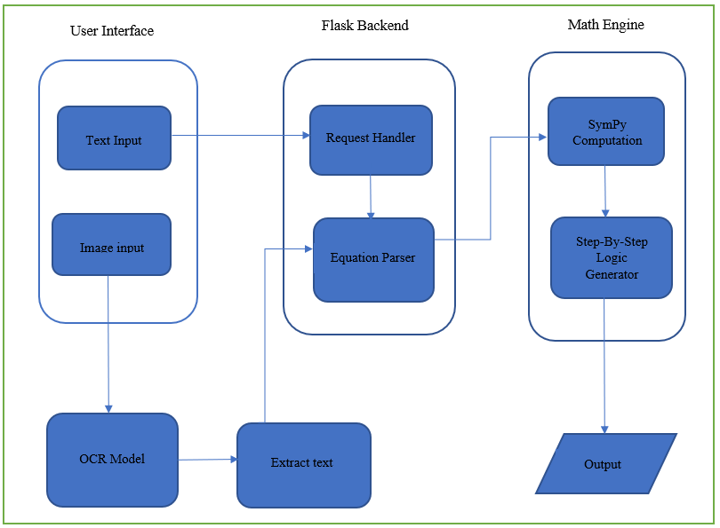
Fig. Workflow of MathMinds
The proposed system follows a layered architecture to ensure modularity, clarity, and efficient processing of Engineering Mathematics problems. The architecture is designed to seamlessly handle both textual and image-based mathematical inputs and generate structured, step-by-step solutions.

- User Interface Layer
The User Interface Layer serves as the interaction point between the user and the system. It allows users to either manually enter mathematical expressions or upload images containing handwritten or printed equations.
Fig. Image to LaTeX Conversion
The system supports two modes of user input: text-based and image-based. When a user enters a mathematical expression in text form, it is first converted into a standardized LaTeX representation to ensure uniformity and accurate symbolic interpretation. In the case of image-based input, the uploaded image containing handwritten or printed mathematical content is processed to extract the mathematical expression, which is then converted into its corresponding LaTeX form. By converting all inputs into LaTeX, the system establishes a consistent intermediate representation for further processing.

- Backend Layer
The Backend Layer acts as the control unit of the system. It receives input from the user interface or OCR module through a request handler, which manages routing and validation. An equation parser then analyzes the extracted text to identify the type of mathematical operation involved, such as integration, Laplace transformation, or matrix computation. The parsed and structured expression is prepared for symbolic evaluation.

- Math Engine Layer
The Math Engine Layer performs the core computational tasks. Using symbolic computation techniques, the engine executes the required mathematical operations. Additionally, a step-by-step logic generator decomposes the solution into intermediate stages, enabling users to understand the complete problem-solving methodology rather than just the final result.
Finally, the Output Module formats the computed result and its corresponding step-by-step explanation into a readable mathematical form. The formatted output is sent back to the user interface, where it is displayed using mathematical rendering tools to ensure clarity, correctness, and ease of interpretation.

- Chatbot
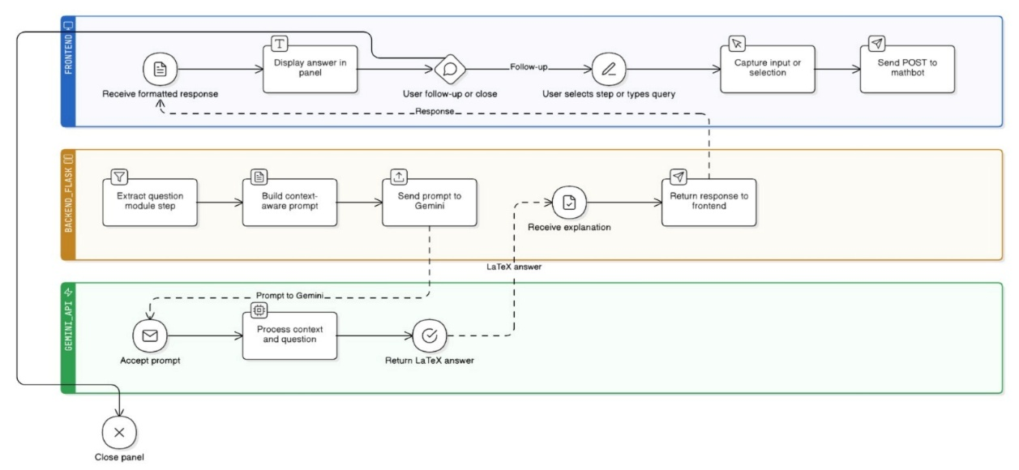
Fig.
The chatbot operates through a layered workflow comprising the frontend, backend task logic, and the Gemini API, as illustrated in the figure. The process begins at the frontend, where the user submits a query or selects a predefined step through the chatbot interface. The input is captured and forwarded to the backend for processing. In the backend task layer, the system first extracts the relevant question or module context and constructs a context-aware prompt by combining the user query with necessary system information. This prompt is then sent to the Gemini API for further processing.
Upon receiving the prompt, the Gemini API analyzes the contextual information and generates a corresponding LaTeX-formatted answer or explanation. The generated response is returned to the backend, which validates and formats it appropriately before forwarding it to the frontend. The frontend then displays the response in the chatbot panel. The system also supports follow-up interactions, allowing the user to refine the query or proceed with additional steps. The workflow continues iteratively until the user chooses to close the panel, ensuring seamless interaction between user input, intelligent processing, and response delivery.

OCR Model Description
- PaddleOCR
PaddleOCR is a general-purpose text recognition system that performs well on clear, printed content commonly found in textbooks, PDFs, and lecture notes. In the context of this project, it is mainly used to extract mathematical expressions from neatly formatted images such as screenshots or scanned question papers. Its structured pipeline allows it to reliably detect text regions and convert them into readable equation strings. While it is efficient and accurate for standard mathematical symbols and linear expressions, it does not fully capture the spatial structure of advanced mathematical notation such as nested fractions or superscripts. Despite this limitation, PaddleOCR plays an important role in ensuring fast and dependable recognition for well-formatted Engineering Mathematics problems.
- Pix2Tex
Pix2Tex is specifically designed to interpret mathematical expressions rather than general text, making it highly relevant to an Engineering Mathematics learning platform. Instead of producing plain text, it converts equation images directly into structured mathematical representations. This ability allows the system to preserve the layout and meaning of complex expressions such as integrals, matrices, differential equations, and transformations. For subjects like EM1 to EM4, where understanding symbolic structure is essential, Pix2Tex enables accurate parsing and step-by-step solution generation. Although it requires higher computational resources, its contribution significantly improves the correctness and educational value of the solutions provided to students.
- EasyOCR
EasyOCR is employed in the system to handle more challenging real-world inputs, particularly handwritten equations or images captured under poor lighting conditions. Since many students rely on mobile phones to click pictures of classroom problems or handwritten notes, EasyOCR helps improve the system’s robustness by recognizing irregular and noisy text. Although its mathematical understanding is limited and it may miss structural relationships between symbols, it serves as an effective fallback when other OCR methods fail. This makes EasyOCR valuable for improving accessibility and ensuring that students can submit doubts without worrying too much about image quality.

Dataset Used
The IM2LATEX-100K dataset is a large-scale, prebuilt benchmark dataset designed for image-to-LaTeX generation tasks. It contains approximately 100,000 paired samples, where each sample consists of a rendered mathematical formula image and its corresponding LaTeX source code.
Unlike traditional tabular datasets, IM2LATEX-100K does not contain predefined numerical features. Instead, features are learned automatically by the model from raw inputs:
- Image Features: Each sample includes a rendered formula image. During model training, visual features are extracted from pixel-level data using convolutional neural networks (CNNs), capturing structural information such as symbols, spatial alignment, and mathematical layout.
- Textual Features: The target output is a sequence of LaTeX tokens. These tokens are converted into embeddings, where each token represents a learned feature in a high-dimensional space.
- Feature Dimensionality: Feature dimensions are model-dependent and vary based on the CNN encoder and sequence decoder architecture used. Therefore, the dataset itself does not impose a fixed feature count.
Attributes | Details
Total Samples | ≈ 103,558 image-formula pairs
Training Samples | ≈ 90,000
Validation Samples | ≈ 5,000
Test Samples | ≈ 5,000
Image Resolution | 160 x 320 pixels
Average Formula Length | ≈ 30-40 LaTeX tokens
Vocabulary Size | ≈ 500-700 unique LaTeX tokens

System Overview
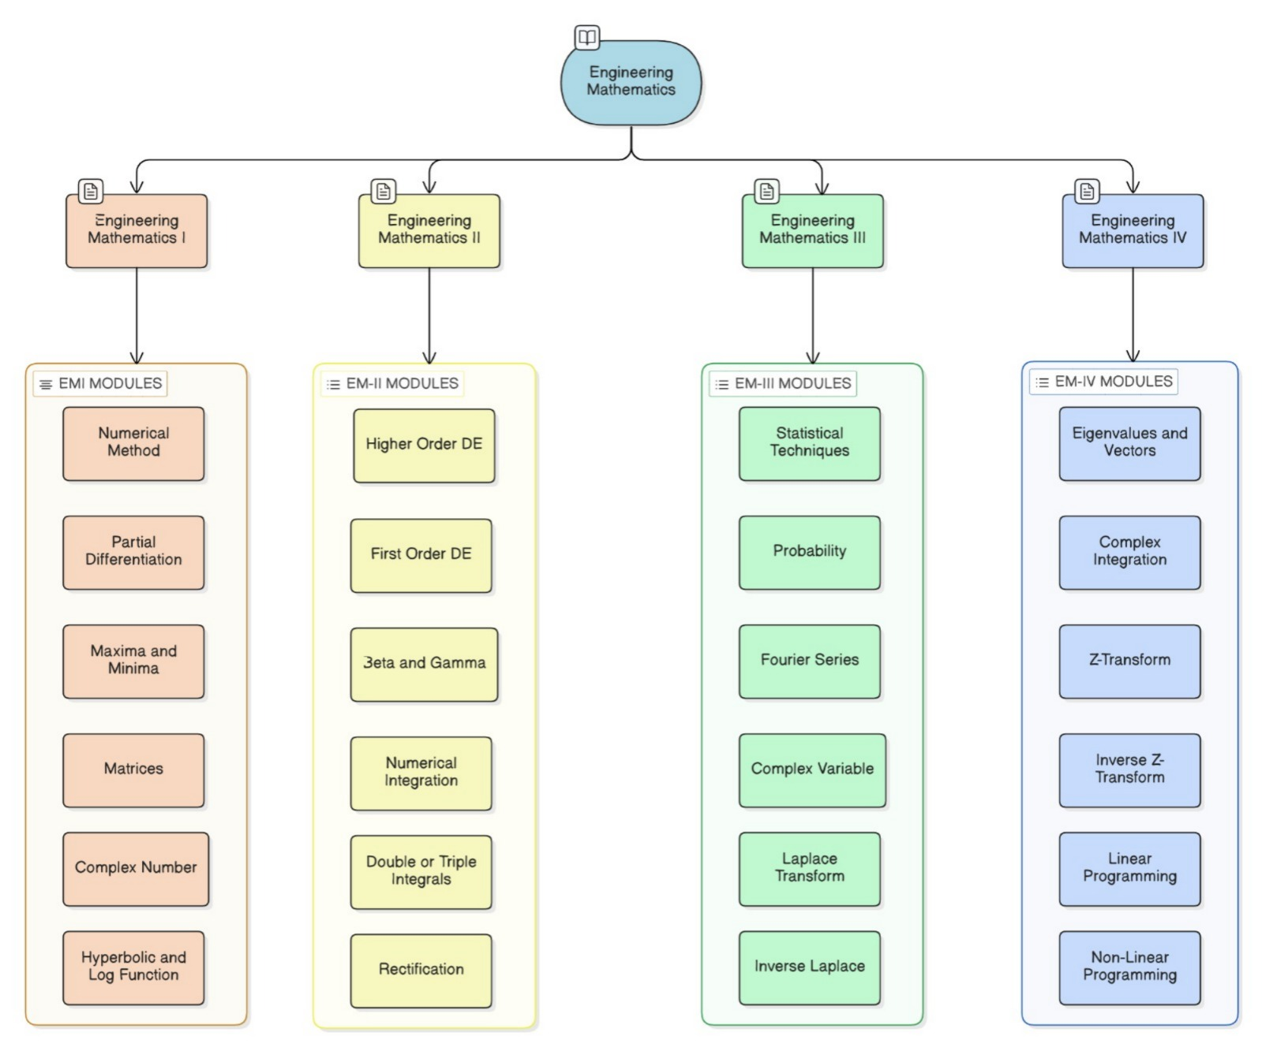
Fig.
The proposed system is organized around the Engineering Mathematics curriculum and is structured into four major divisions: Engineering Mathematics I, II, III, and IV. Each division is further broken down into topic-wise modules that represent the core mathematical areas taught in undergraduate engineering programs. These modules cover a wide range of concepts such as numerical methods, differential equations, complex variables, transforms, probability, and optimization techniques. This modular organization allows the system to provide focused learning and problem-solving support for each topic independently. By structuring the platform in alignment with the academic syllabus, the system ensures relevance and completeness while enabling students to navigate concepts systematically. To support effective learning, a dedicated formula sheet is integrated into each module, providing students with quick access to important formulas and key concepts for revision and reference. This feature helps learners recall fundamental relationships while solving problems, reducing cognitive load and improving problem-solving efficiency. By combining structured modules, formula references, and guided solution explanations, the system functions as a comprehensive digital learning assistant aimed at strengthening conceptual understanding and analytical skills in Engineering Mathematics
Model Evaluation
Metrics | PaddleOCR | EasyOCR | Pix2Tex
Character Recognition Accuracy (%) | 92.4 | 78.1 | 96.8
Precision (%) | 78.6 | 72.3 | 95.9
Recall (%) | 91.2 | 76.4 | 95.1
F-1 Score (%) | 90.1 | 78.8 | 95.5
LaTeX Parsing Success Rate (%) | 81.3 | 74.5 | 92.7
Pix2Tex outperforms general OCR models in all expression-level metrics due to its direct image-to-LaTeX decoding approach, making it highly suitable for Engineering Mathematics problems involving complex notation.

PaddleOCR demonstrates strong character-level accuracy but shows limitations in preserving mathematical structure, particularly for multi-line or nested expressions.

EasyOCR, while effective for basic text recognition, exhibits lower expression accuracy and parsing success for advanced mathematical symbols.
Higher LaTeX parsing success rates directly correlate with improved symbolic computation reliability and step-by-step solution generation.

Results
Model | Accuracy (%) | Precision (%) | Recall (%) | F-1 Score (%)
Tesseract OCR | 67 | 65 | 58 | 61
InftyReader | 87 | 88 | 82 | 85
Im2LaTeX | 92 | 91 | 89 | 90
MathPix | 94 | 94 | 93 | 93
CNN+RNN | 81 | 80 | 77 | 78
CNN+LSTM | 80 | 78 | 79 | 78
PaddleOCR | 88 | 88 | 84 | 86
EasyOCR | 79 | 80 | 76 | 78
Pix2Tex | 92 | 93 | 91 | 92

The primary objective of the proposed system is to support Engineering Mathematics learning by accurately interpreting student-submitted equations and generating step-by-step symbolic solutions. Unlike generic OCR applications, this task demands not only text recognition but also preservation of mathematical structure, flexibility across input types, and seamless integration with symbolic computation.
Engineering Mathematics problems involve two-dimensional layouts such as fractions, matrices, integrals, summations, and transforms. Pix2Tex directly converts images into structured mathematical representations, preserving spatial hierarchy and operator precedence. This makes it significantly more suitable than traditional OCR engines, which treat equations as linear text and often lose structural information essential for symbolic evaluation.
While high-accuracy systems such as MathPix exist, it requires cloud access or proprietary APIs, limiting reproducibility and offline academic usage. PaddleOCR and EasyOCR offer efficient, open-source alternatives that perform reliably for printed and semi-structured equations, ensuring fast response times and system scalability. This balance is crucial for a student-facing educational platform.
Students submit equations in varied formats, including typed text, screenshots, and handwritten notes. No single OCR model performs optimally across all scenarios. By combining general-purpose OCR engines with a math-aware recognition model, the system remains robust to variations in handwriting, image quality, and formatting which acts as an advantage over specialized models trained on narrow datasets.
The selected models produce outputs that integrate smoothly with symbolic computation engine(Sympy) used in our project, enabling the generation of step-by-step solutions. This transparency aligns with pedagogical goals, ensuring the system acts as a learning aid rather than a black-box solver. Many alternative models prioritize output accuracy but lack explainability, reducing their educational value.

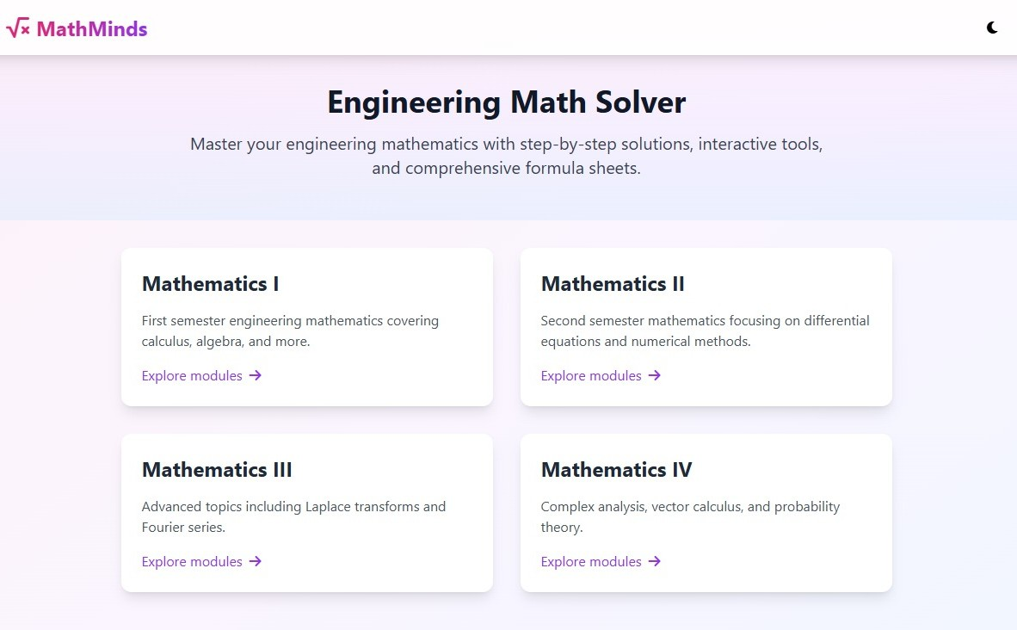
Fig. The web interface Dashboard
After opening the MathMinds interface, as student can navigate through semester-wise engineering Mathematics module and can select their required subject.
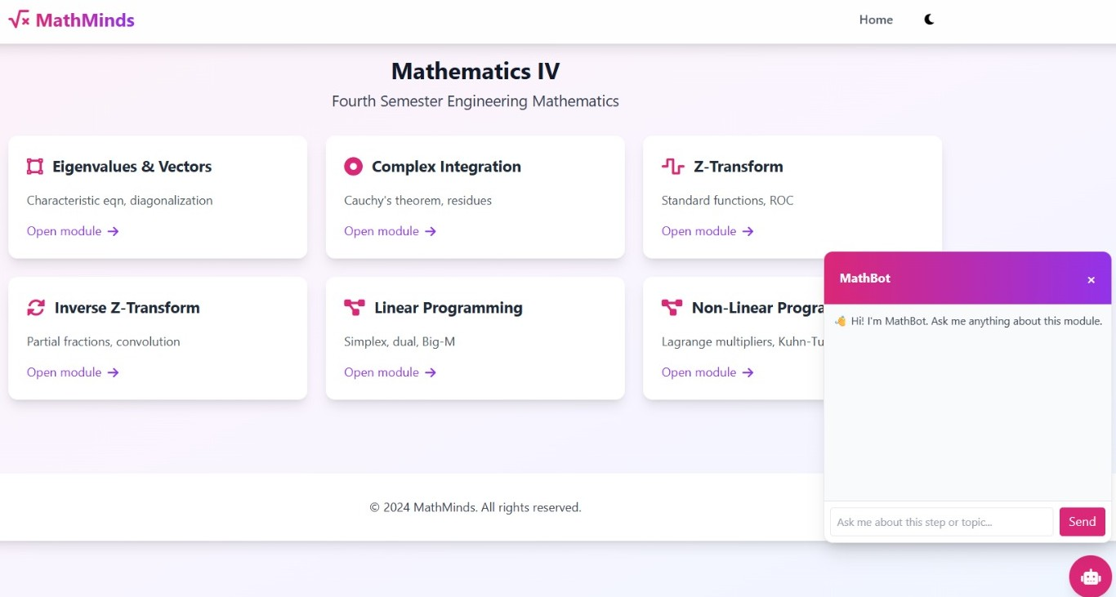
Fig. Web Interface For c
After selecting Mathematics IV, the student is presented with all the major fourth-semester engineering Mathematics topics. From here on the student can choose a specific module such as Eigen vector and values, complex integration, Z-Transform, Inverse Z-transform, Linear programming and non-linear programming.
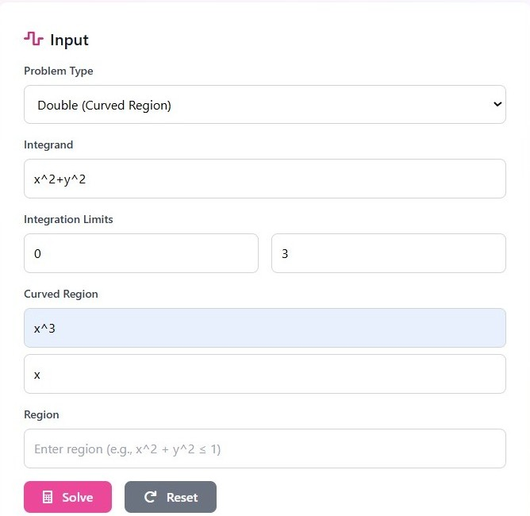
Fig. Text input for Double Integration Problem
Here we have chosen the module double integration, and are solving double integrals over a curved region.
$\int_{0}^{3}{\int_{x^{3}}^{x}{(x^{2}+ y^{2})dydx}}$
The above equation gets converted into its LaTeX format and is

$$\left\{\backslash int_\{0\}^\{3\}\backslash int_\{x^\{3\}\}^\{x\}(x^\left\{2\right\}+\backslash y^\{2\})\backslash ,dy\backslash ,dx\right\}$$
The LaTeX format of the equation is then forwarded to the backend logic generator
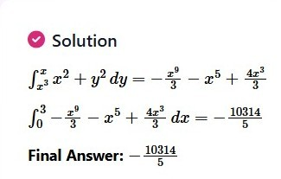
Fig.
In the first step the backend system performs integration with respect to ‘y’ which is the inner integral
$$\int_{x^{3}}^{x}{\left(x^{2}+y^{2}\right)dy=\left[x^{2}y+ \frac{y^{3}}{3}\right]{x^{3} \atop x}}$$
After applying the limits y = x³ to y = x:
$$=\left(x^{3}+ \frac{x^{3}}{3}\right)-\left(x^{5}+ \frac{x^{9}}{3}\right)= \frac{{4x}^{3}}{3}- x^{5}- \frac{x^{3}}{9}$$
In the second step the system performs integration with respect to ‘x’ which is the outer integral
$$\int_{0}^{3}{\left(\frac{{4x}^{3}}{3}- x^{5}- \frac{x^{3}}{9}\right)dx=\left[\frac{x^{4}}{3}- \frac{x^{6}}{6}- \frac{x^{10}}{30}\right]{3 \atop 0}}$$
Apply limits to the equation as x = 3 to x = 0:
$$=27- \frac{729}{6}-\frac{59049}{30}$$
Take the common denominator as 30:
$$= \frac{810-3645-59049}{30}= \frac{-61884}{30}= \frac{-10314}{5}$$
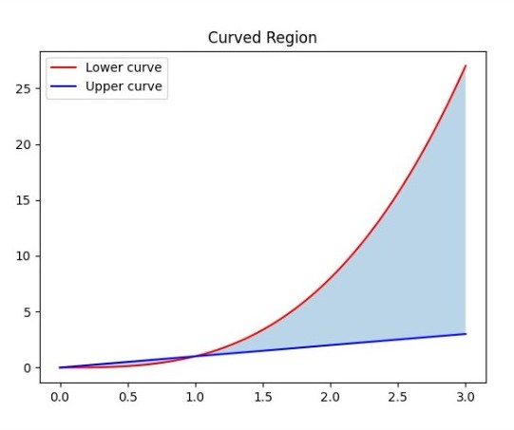
Fig.
. The figure presents the evaluation of a double integral over a curved region defined by the functions y=x³ and y = x within the interval 0≤x≤3. The shaded plot illustrates the region of integration, and the corresponding analytical solution is obtained by sequential integration with respect to y and x. The resulting negative value reflects the reversal of upper and lower bounds over the specified domain.

Limitations
Despite demonstrating the effectiveness of a digital doubt-solving platform for Engineering Mathematics (EM1–EM4), the current system has certain limitations. The solution generation mechanism is primarily rule-based and relies on predefined solution paths, which restricts its ability to handle unseen or highly complex problem variations. While this approach ensures correctness and clarity for commonly encountered syllabus-based questions, it limits scalability across diverse mathematical domains. Additionally, the system’s performance is influenced by the clarity and quality of the input questions, which may affect the interpretation of complex multi-line derivations. The platform also lacks adaptive learning capabilities, meaning it does not dynamically adjust problem difficulty or explanations based on individual learner performance. Furthermore, evaluation is currently limited to qualitative observations and sample problem testing, without large-scale user studies or statistical learning outcome analysis.

Future Scope
The proposed system offers significant potential for future enhancements. One key extension is the integration of intelligent solution engines capable of dynamically solving unseen Engineering Mathematics problems using symbolic reasoning or machine learning models. Adaptive learning mechanisms can be introduced to personalize content based on a student’s strengths, weaknesses, and learning pace. Expanding the problem database to include advanced numerical methods, higher-order differential equations, and real-world engineering applications would further increase academic relevance. Additionally, incorporating analytics-driven feedback and performance dashboards can help students and educators track progress more effectively. The platform can also be extended to mobile and cloud-based environments, enabling wider accessibility and real-time academic support. With these enhancements, the system can evolve into a comprehensive intelligent tutoring solution for engineering education.

Conclusion
The project effectively addresses one of the major challenges faced by engineering students understanding and solving complex problems in Engineering Mathematics (EM1–EM4). Many students struggle to grasp fundamental concepts and step-by-step solution methods, often relying solely on final answers without clarity on the reasoning behind them. This platform bridges that gap by providing detailed, concept-oriented explanations that guide learners through each stage of problem solving. By offering topic-wise modules and personalized doubt-solving support, it transforms the traditional learning experience into an interactive and self-paced process. The system helps students strengthen their conceptual understanding, build confidence in applying mathematical methods, and reduce academic dependency on external coaching or textbooks. Ultimately, this project serves as a digital learning companion designed to enhance analytical thinking and improve academic performance in core Engineering Mathematics subjects.

References
[1] Amal Vijay G., Rosilin R, Gunanidhi D., Sobana K. S. and Mrs. R. Umamageshwari. (2025). SOLVE IT (MATH SOLVER). International Journal of Research in Engineering & Science ISSN:(P) 2572-4274 (O) 2572-4304, 9(2), 1–7.
[2] Vincent Liu, Ehsan Latif, and Xiaoming Zhai. (2025). Advancing Education through Tutoring Systems: A Systematic Literature Review.
[3] Wenqi Zhang, Yongliang Shen, Qingpeng Nong, Zeqi Tan, Yanna Ma, and Weiming Lu. 2023. An Expression Tree Decoding Strategy for Mathematical Equation Generation. In Proceedings of the 2023 Conference on Empirical Methods in Natural Language Processing, pages 439–456, Singapore. Association for Computational Linguistics.
[4] Jordan Meadows, André Freitas; Introduction to Mathematical Language Processing: Informal Proofs, Word Problems, and Supporting Tasks. Transactions of the Association for Computational Linguistics 2023; 11 1162–1184.
[5] Zuoyu Yan, Xiaode Zhang, Liangcai Gao, Ke Yuan and Zhi Tang. (2020). ConvMath: A Convolutional Sequence Network for Mathematical Expression Recognition.
[6] Meurer A, Smith CP, Paprocki M, Čertík O, Kirpichev SB, Rocklin M, Kumar A, Ivanov S, Moore JK, Singh S, Rathnayake T, Vig S, Granger BE, Muller RP, Bonazzi F, Gupta H, Vats S, Johansson F, Pedregosa F, Curry MJ, Terrel AR, Roučka Š, Saboo A, Fernando I, Kulal S, Cimrman R, Scopatz A. 2017. SymPy: symbolic computing in Python.
[7] Kulik, J. A., & Fletcher, J. D. (2016). Effectiveness of Intelligent Tutoring Systems: A Meta-Analytic Review. Review of Educational Research, 86(1), 42-78.
[8] Akın, A. The effectiveness of web-based Mathematics instruction (WBMI) on K-16 students’ mathematics learning: a meta-analytic research. Educ Inf Technol 27, 8015–8040 (2022).
[9] Radian Belu, Lucian Ionel Cioca, Richard Chiou (2017). Symbolic Computation Applications in Power Engineering Education. American Society for Engineering Education-ASEE
[10] Yibo Yan and Jiamin Su and Jianxiang He and Fangteng Fu and Xu Zheng and Yuanhuiyi Lyu and Kun Wang and Shen Wang and Qingsong Wen and Xuming Hu (2024). A Survey of Mathematical Reasoning in the Era of Multimodal Large Language Models. arXiv:2412.11936.
[11] Thanh-Nghia Truong, Cuong Tuan Nguyen, Richard Zanibbi, Harold Mouchère, Masaki Nakagawa, A survey on handwritten mathematical expression recognition: The rise of encoder-decoder and GNN models, Pattern Recognition, Volume 153, 2024, 110531, ISSN 0031-3203
[12] Shree Mitra, Ritabrata Chakraborty, Nilkanta Sahu (2025). Mask & Match: Learning to Recognize Handwritten Math with Self-Supervised Attention. arXiv:2508.06107.

